Week 1

S.E=std of error of mean is less than the pop std ,because we expect the means of sampling dist to be less variable than the pop

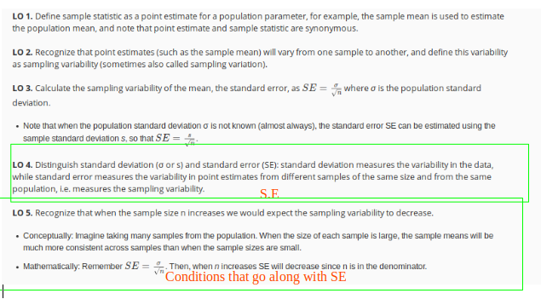

<https://gallery.shinyapps.io/CLT_mean/>

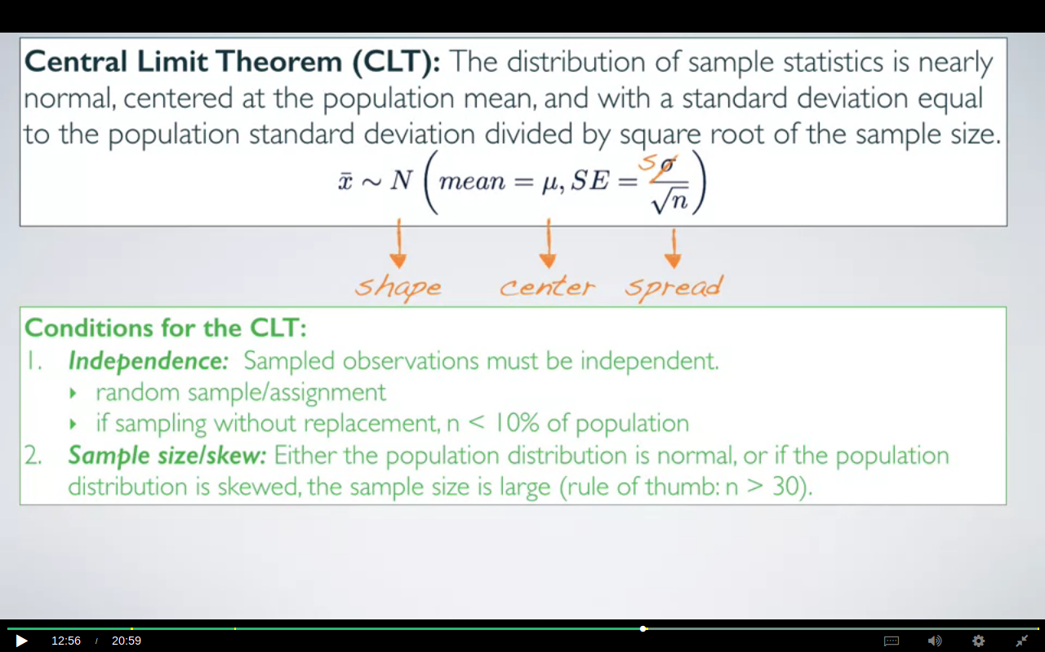

if the pop dist is normal then the sampling dist is also going to be normal regardless of the sample size however if it is not then we would have to take the sample size>= 30. the more skewed a dist is the larger the s.s will be needed in order to follow the CLT.

Often times We do not know what dist our population is following,so for those scenarios we plot our sample data and assume that both follow the same dist.

We need to concentrate on sample dist before doing any calculations ,for instance the dist of the incomes can’t be the normal as there’s no certain limit to what a person can earn.

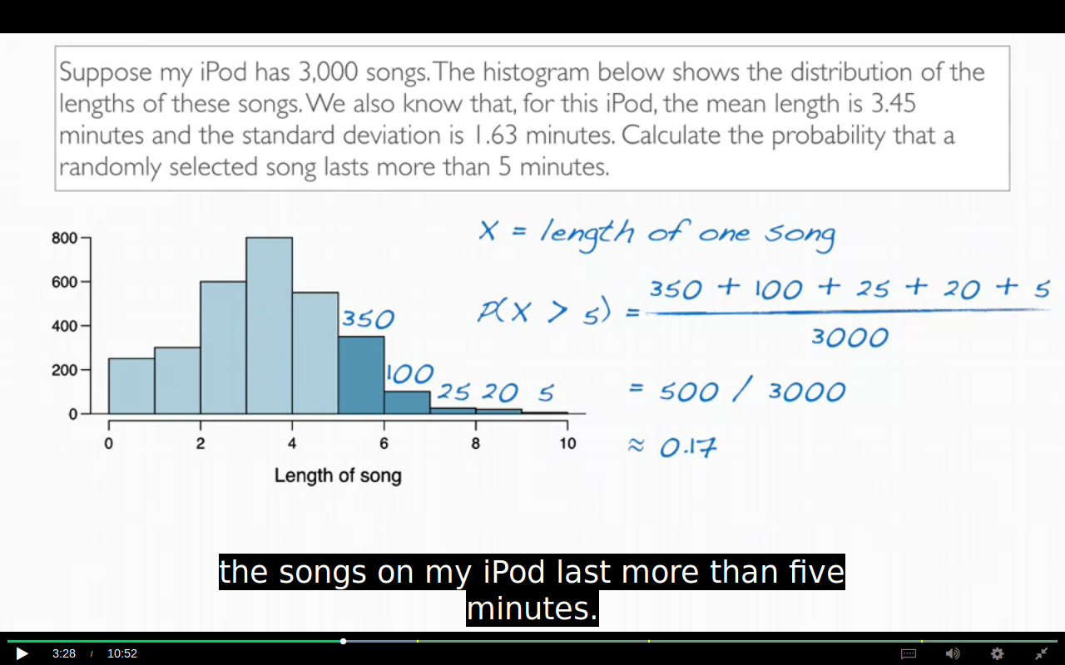

The methods for calculating the prop using Z table can;t be applied here as the dist is right skewed.

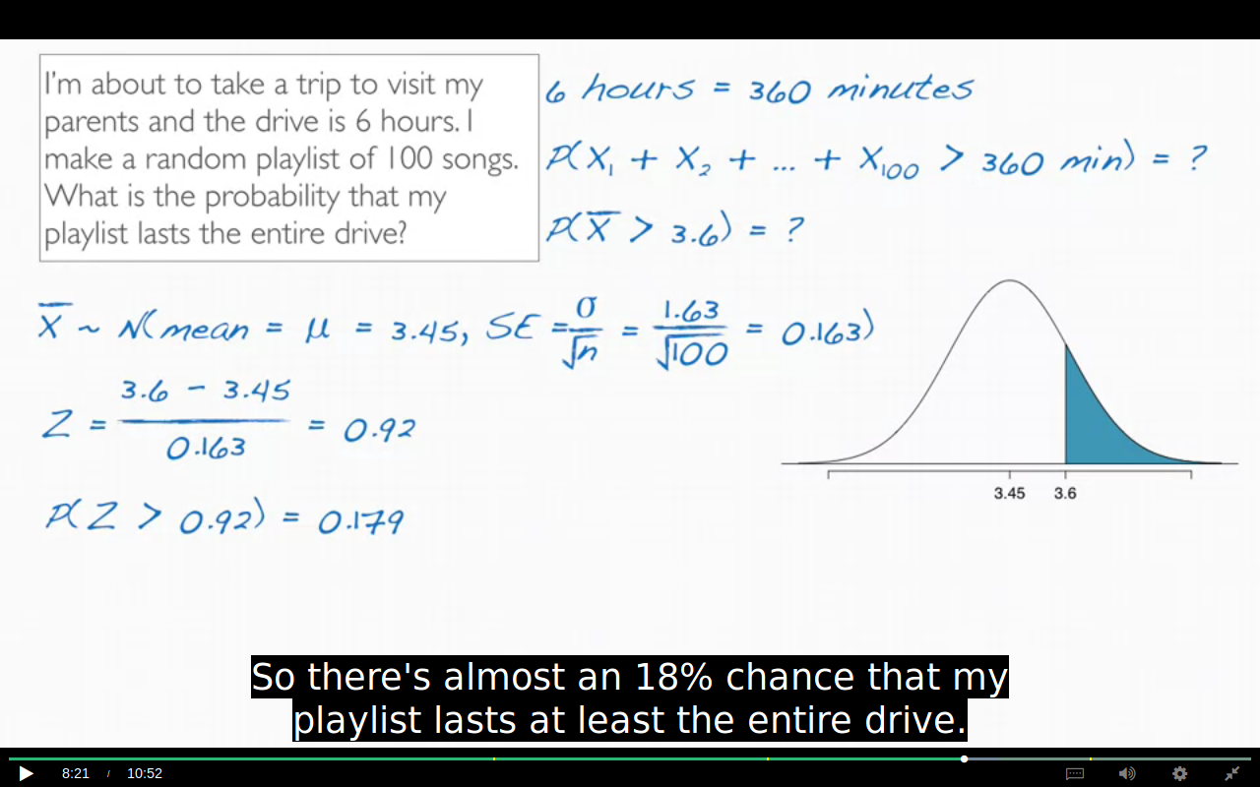

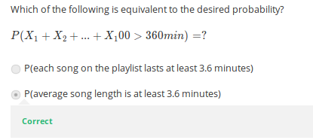

Think why this is true ?

## Q. When do I use sigma /sqrt(n)?

A. You always divide by sqrt(n). However, occasionally the square root of n sometimes equals 1 (making it just σ in the denominator. for example, if you are choosing one person and trying to figure out the probability their weight is under x pounds, then n=1. In other words, if you are calculating a [z-score](http://www.statisticshowto.com/probability-and-statistics/z-score/), you can always use √(n).

We measure the variability of individual observations with standard deviations. We measure the variability of sample means with standard errors.So whatever the observation is that you plug in in

the numerator in your Z-score, its variability belongs in the denominator.

In other words, our observation is an X bar, and not an X.